THE SOVEREIGN MISFIT FARM MANIFESTO
What We Become Together
We are the ones who never quite fit — and stopped trying to. We are the ones who looked at the way things are and said: there has to be another way. Not a retreat from the world. A proof of concept for a better one.
Sovereign Misfit Farm is not a commune, not a compound, not an escape. It is a community built on a simple wager: that twelve households, bound by covenant and sustained by land, can build something that lasts — something that feeds, something that heals, something that can be given away to anyone brave enough to try it themselves.

What the Ancestors Already Knew
The Haudenosaunee planted corn, beans, and squash together — three sisters, each sustaining the others. The corn gives the beans something to climb. The beans fix nitrogen for the corn. The squash shades the soil and holds the moisture in. No one sister survives alone.
We are not inventing something new. We are remembering something old. For ten thousand years, human beings lived in communities of this scale — small enough to know every face, large enough to carry every burden. They managed shared land without deeds. They resolved conflict without courts. They fed their families without corporations.
They knew what we are relearning: that the land is not a commodity, labor is mutual, governance is local, and the calendar is set by the earth — not by institutions.

The Sovereignty Ethic
Be who you are — so long as it doesn't harm yourself, others, the community, or the land.
This is the whole law.
It means: eat what you eat. Pray how you pray. Love who you love. Raise your children as you see fit. Build the house that suits your bones. Keep the hours your body keeps.
It also means: when your freedom touches someone else's, you talk about it. When the land says stop, you stop. When the community needs you, you show up. Sovereignty is not isolation. It is responsibility — to yourself and to the people who chose to stand beside you.

The Council of Twelve
Twelve is old. Twelve months. Twelve hours of light. Twelve apostles, twelve Olympians, twelve knights, twelve jurors. Twelve is the number of a full circle — not too few to carry the weight, not too many to lose each other's faces.
Each seat held by a household — single, couple, or family. Each household carries the same weight: same buy-in, same vote, same voice. No tiers, no ranks, no legacy seats. You earn your place by choosing to be here and being chosen in return.
Children born into this community belong to it fully — but no one inherits a seat. Sovereignty means you earn your own place.

The Exchange Covenant
Every member gives. Every member receives. The form of the gift changes — capital, labor, skill, knowledge, time, care — but the weight is equal.
No one's contribution is valued above another's by nature of its form. The person who wires the solar panels and the person who holds a crying child at 2 a.m. are both keeping the lights on.
The CSA is our engine. We grow food, we feed our neighbors, the money comes back, the cycle continues. But the CSA is also a covenant with the surrounding community — a bridge between our little world and the larger one. We are not an island. We are neighbors who happen to share a deed.

Living Creatures on Sovereign Land
We are not a vegan community. We are not a meat farm. We are a sovereign community where individuals make their own choices about what they eat.
The community keeps animals — chickens for eggs, goats for milk and mischief, bees for honey and pollination, dogs for protection, cats because every barn needs a cat. These animals are named, not numbered. They are cared for with dignity. They live well.
If you hunt, you hunt. If you don't, you don't. If you eat only plants, the community table will always have a place for you. If you eat everything, same table, same welcome. What matters is not what you put in your body — it's whether you can sit across from someone who chose differently and still call them family.

A Village, Not a Fortress
We build close, not scattered. Private dwellings around a shared commons — your own door, your own space, your own quiet. But when you open that door, you step into a village. Children playing. Someone cooking. Tools being shared. A fire burning.
This is how the Yoruba built. This is how the Pueblo built. This is how every human community built until we decided that isolation was the same thing as independence.
It's not. Independence is choosing your people. Isolation is having no one to choose.

The Land Remembers
We do not own this land. We tend it. The trust holds the deed because the deed is a fiction — the land was here before deeds, before courts, before any of us. It will be here after.
Our covenant with the land is older than our covenant with each other: leave it better than you found it. Plant more than you harvest. Build soil, not just structures. Let the wild edges stay wild. The deer, the hawks, the snakes, the invisible things in the soil — they were here first. We are the newcomers. We act accordingly.

The Lie of Scarcity
They told you there isn't enough. Not enough land. Not enough room. Not enough to go around. They told you the only way to have a home is to bid against your neighbor for a piece of earth that costs more every year and gives back less. They told you this so many times you stopped questioning it.
It is a lie. Here is the math.
There are 131 million households in the United States. Our model puts twelve households on thirty acres — two and a half acres per family, with room to grow food, raise animals, and leave the wild edges wild. To house every household in America this way would take 334 million acres. That sounds like a lot. It is less than fifteen percent of the land in this country. It is less than half of what is currently called farmland. The land exists. It has always existed.
What doesn't exist is the will to distribute it. A quarter-acre suburban lot produces nothing — no food, no habitat, no soil, no community. It costs you a mortgage and gives you a lawn. Our model puts the same number of people on the same amount of earth and feeds them. It builds soil instead of depleting it. It supports pollinators instead of poisoning them. It sequesters carbon instead of burning it. The question is not whether there is enough land for everyone to live this way. The question is whether we can afford to keep living the way we do now.
Scarcity is not a fact. It is a story told by people who profit from your belief in it. The land is here. The model is here. The only thing missing is the courage to stop believing the lie.

The Network — We Do Not Franchise, We Pollinate
This model is not ours to keep. Every document — the covenant, the financial model, the legal structure, this manifesto — belongs to anyone who needs it.
If twelve households in New Mexico or Wisconsin or Maine read this and say "we can do that too," then we've succeeded at something bigger than a farm. We've proven that another way of living is not only possible but repeatable.
Each community is sovereign. Each council is independent. But the seeds travel. The knowledge travels. The solidarity travels.
We are not building one farm. We are building a proof of concept for a thousand.
This is not utopia. Utopia means "no place." This is a real place — with mud and debt and disagreements and broken tractors and 2 a.m. goat emergencies.
But it is also a place where your children grow up knowing every adult by name. Where the food on your table came from soil you tended. Where the roof over your head was raised by hands that love you. Where you are known — fully, honestly, without performance — and you are still welcome.
That's not utopia. That's just a good life.
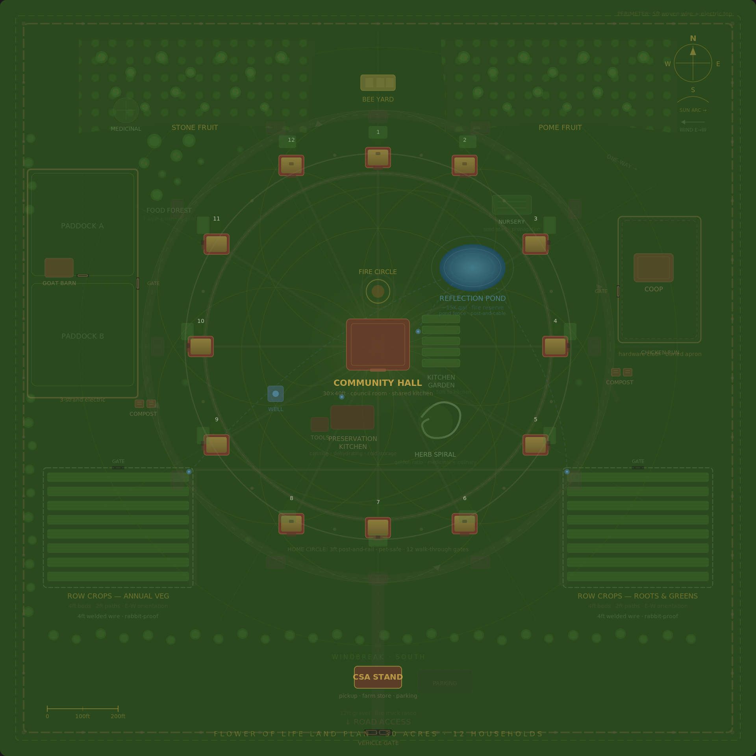
This is what it looks like. Twelve homes. Shared land. Sacred geometry. A village.
Come build it with us.

